MySQL Installer 8.0.x
On ubuntu : https://www.mysqltutorial.org/getting-started-with-mysql/install-mysql-ubuntu/
Go to : https://dev.mysql.com/downloads/mysql/
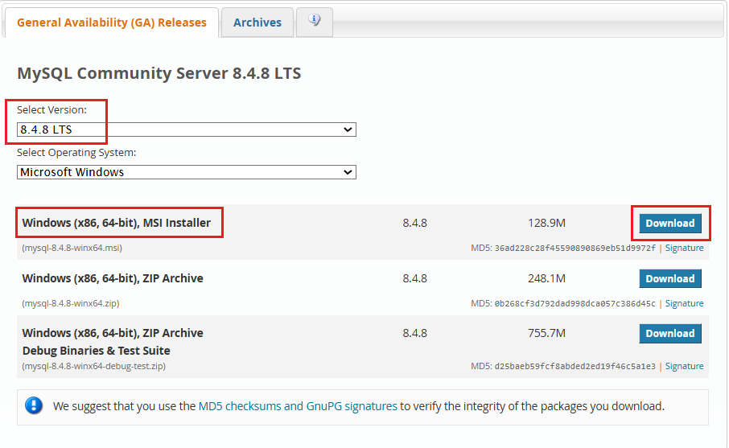
- Select the highlighted version – 8.4.8 LTS. DO NOT go for 9.6.0 innovation
- There are several ways to install Mysql:
1) use windows .msi (Microsoft installer). We are going to install using msi
2) download zip file (We are NOT using this)
- In next screen, click on download link (as highlighted)
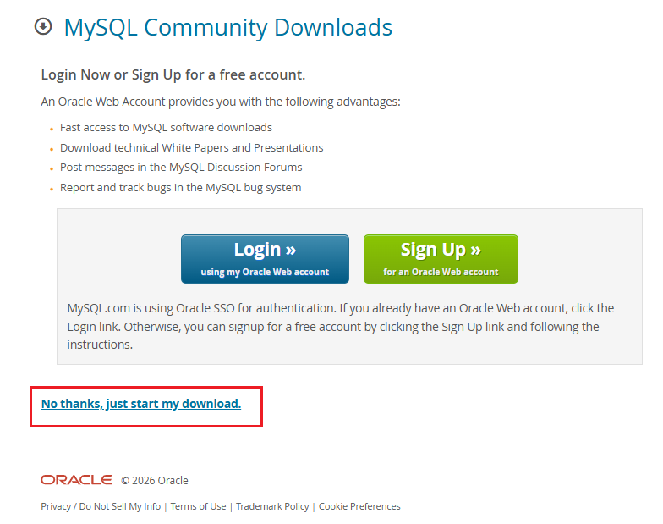
- The msi file (mysql-8.4.8-winx64.msi) is now downloaded.
- Double click on file to begin installation
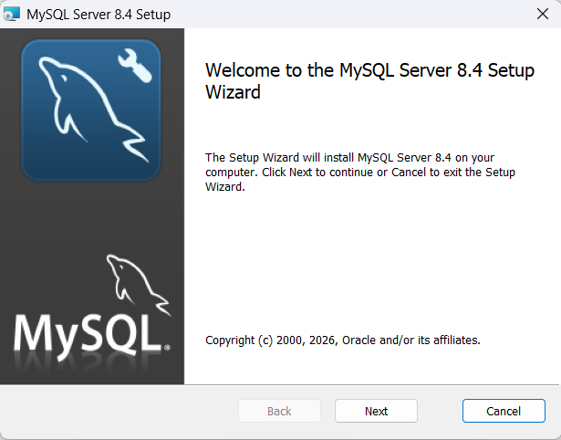 | 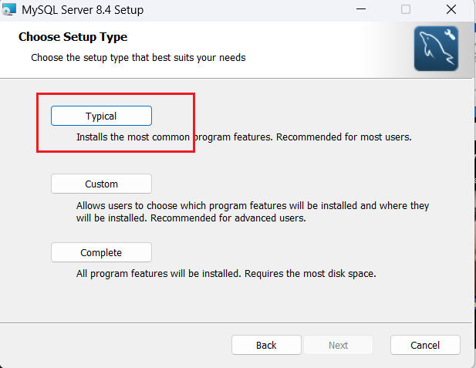

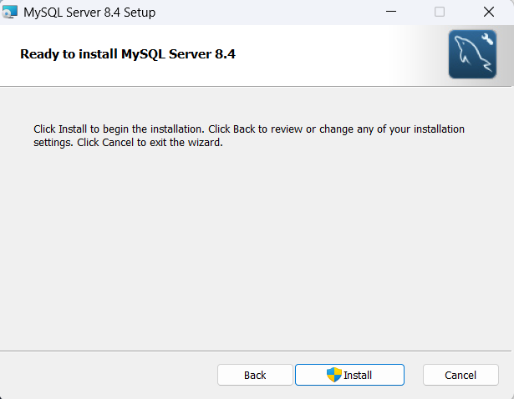 | - Not sure if this screen comes up in ver 8.4.x. This screen we used to get in version 8.0.1  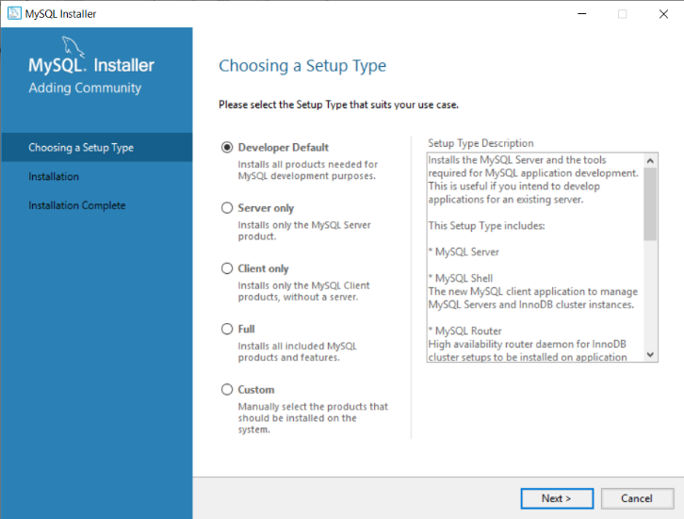

- The Developer default option will install everything, including workbench, server etc
- Choose the custom option:
- Select 2 options and push them into RHS pane.
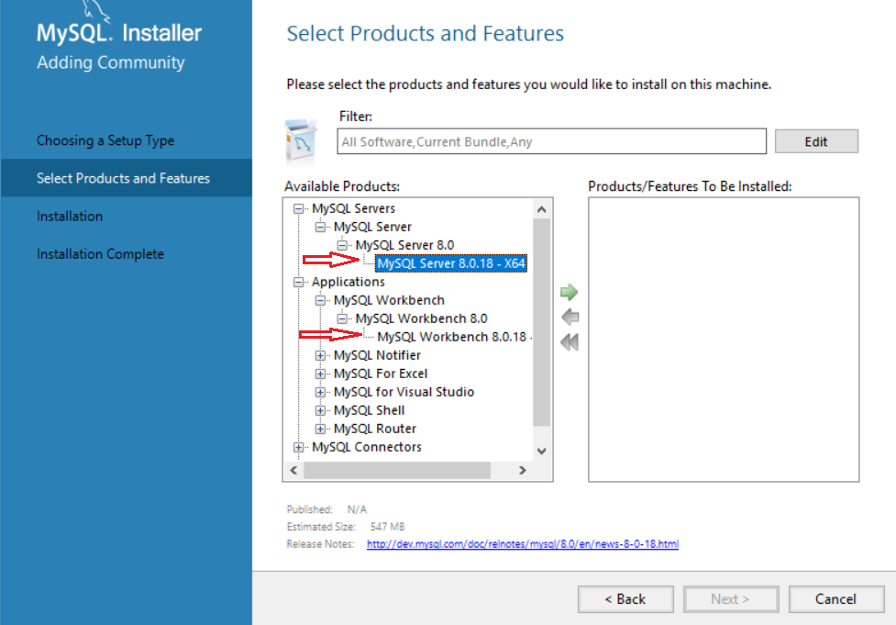

- It must look like this:
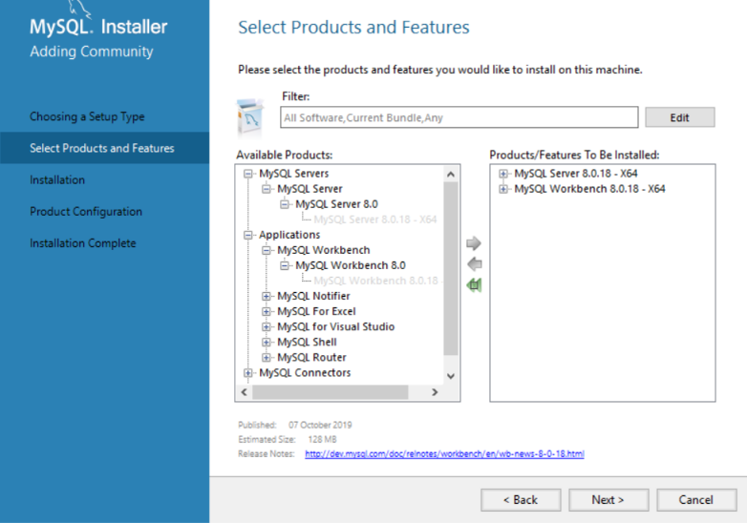
- So finally, these are my 4 choices:
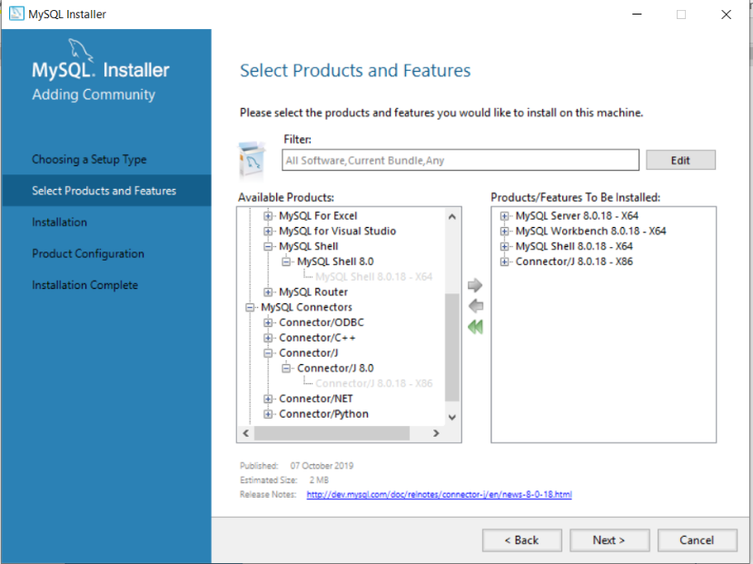
- Click on execute to install the packages. Typically installs in:
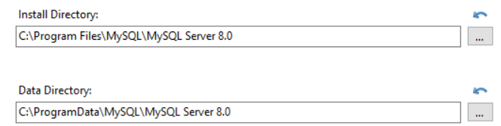
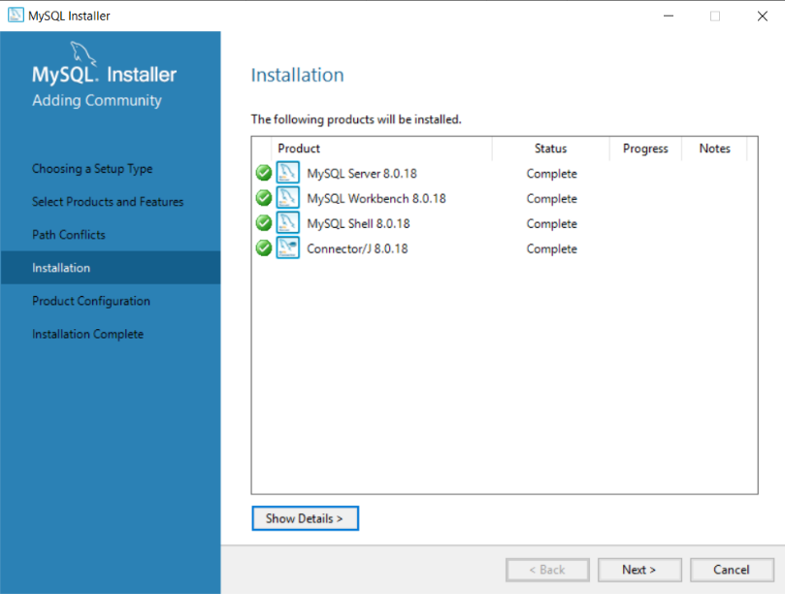

- Click on next for configuring product:
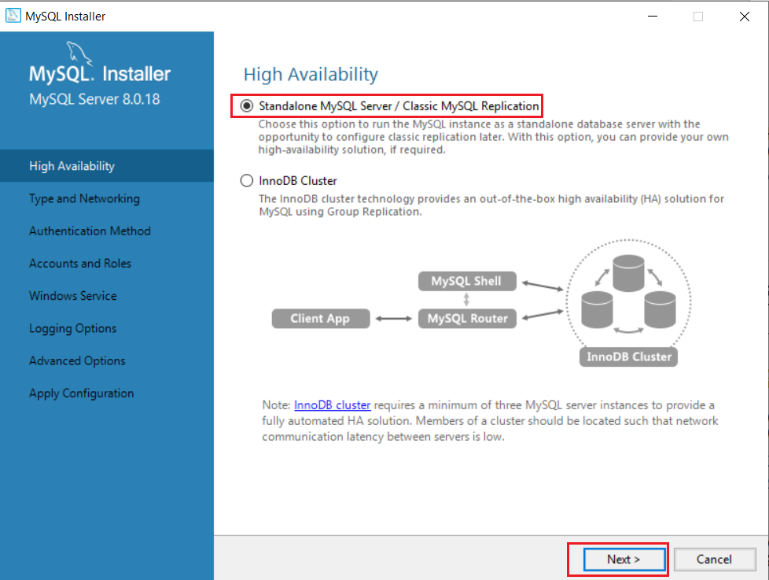

- Select highlighted portions in above figure. No change reqd in next screen
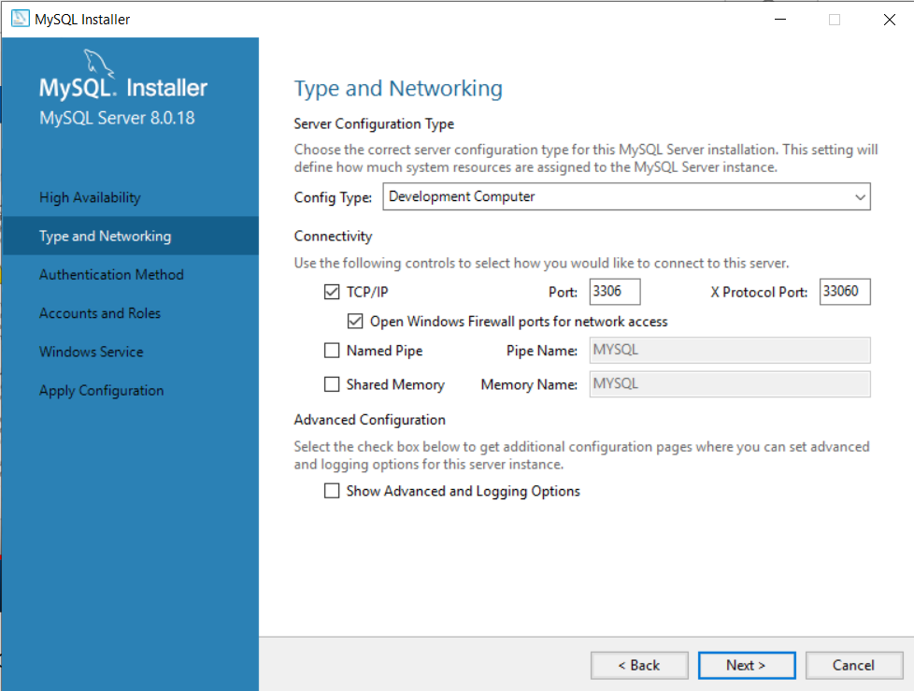

Use first option and click next:
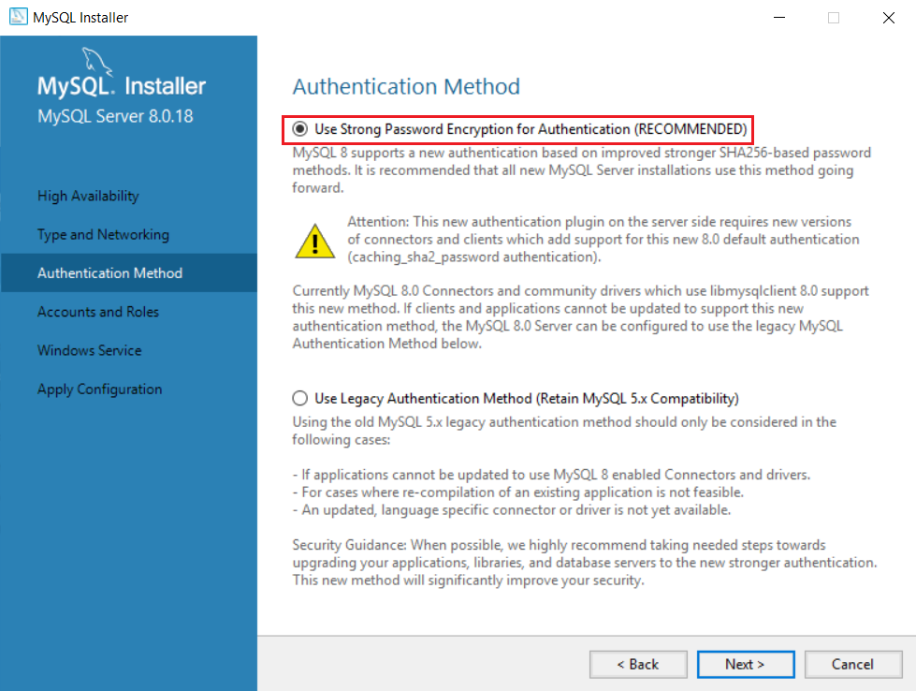
I set the password as root123 (Very important to remember the password you set)

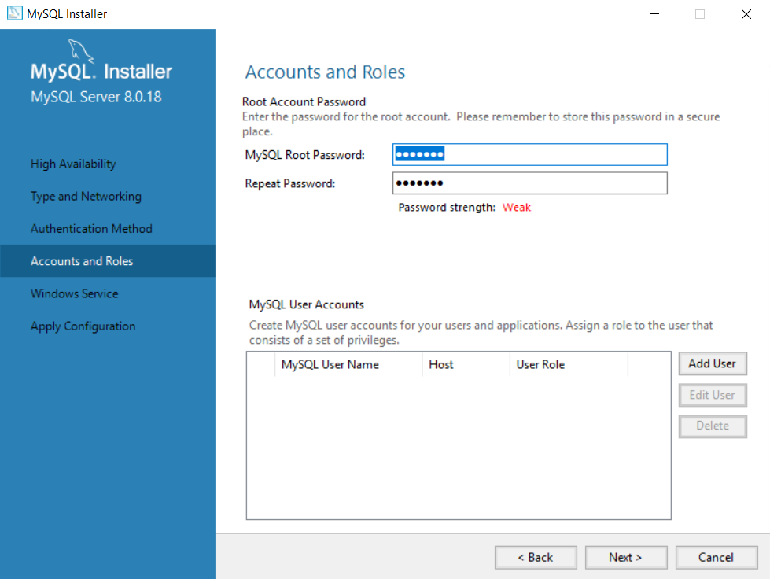
The remaining screens are as is. On last screen, simply click execute button:
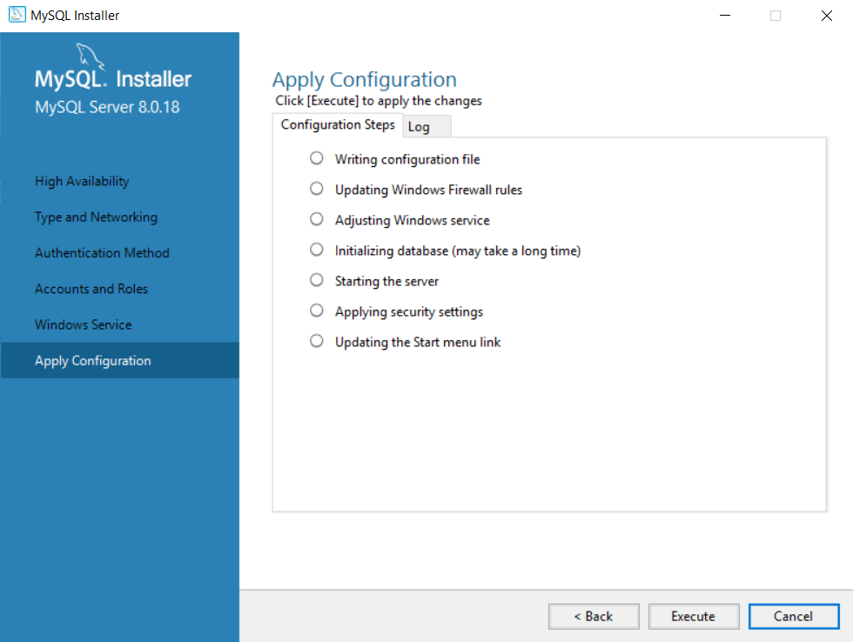

- After clicking on Finish, the Workbench starts automatically. You will see this home screen.
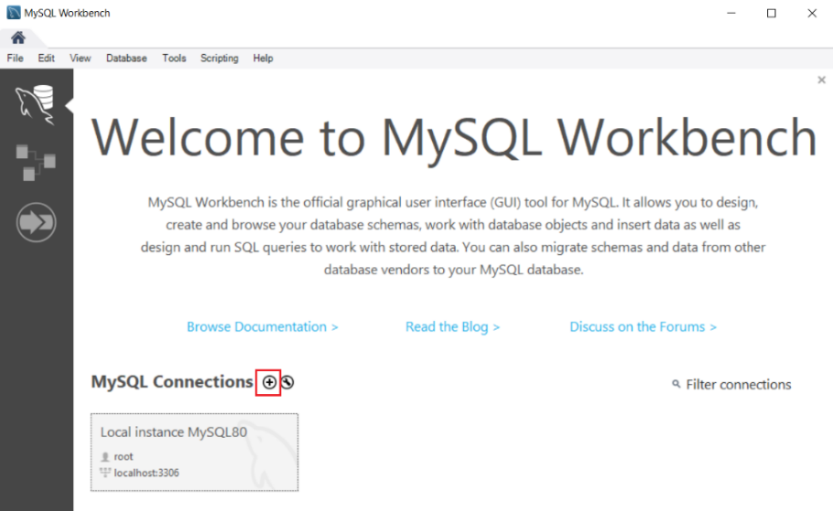

- Test MySql:
- Open MySql command line client:
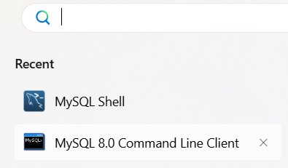
It directly asks for password
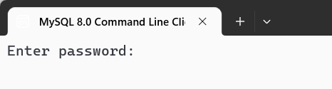

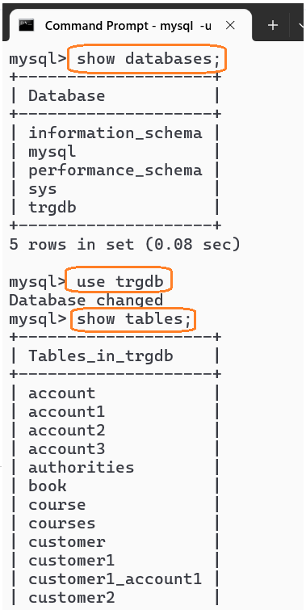
If show databases works, we are good to go

Working with Workbench
We need to create a new connection. Click on the (+) button (highlighted)

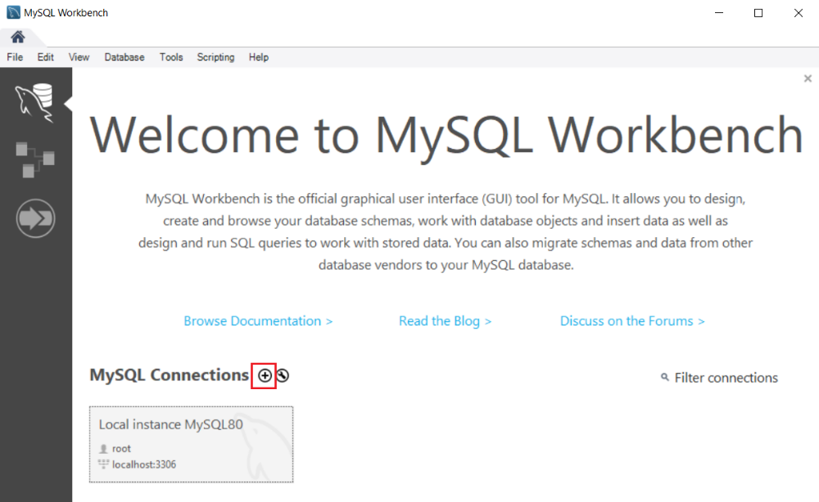
You can connect to a MySQL Server using the Database > Connect to Database… menu or click the + button that is located next to the MySQL Connections.
Click the + button next to the MySQL Connections to continue.
Enter the connection name e.g., Localhost/training etc. You can name it whatever makes sense to you. By default, the username is root. If you use a different user account, you can change it in the Username textbox.
Click the Test Connection button to test if the connection to the MySQL Server is successful or not. Then click the OK button if the connection is established successfully.
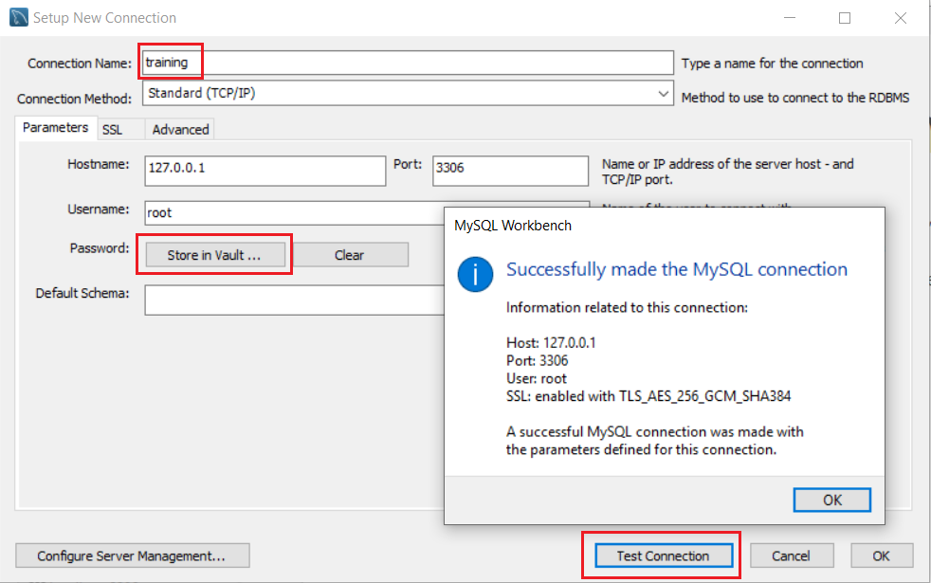

I simply entered a name for connection – training, stored password and tested the connection. All seems ok. Leave the default schema as is – blank. All the other fields are automatically populated
Press ok. You will see the newly created connection:
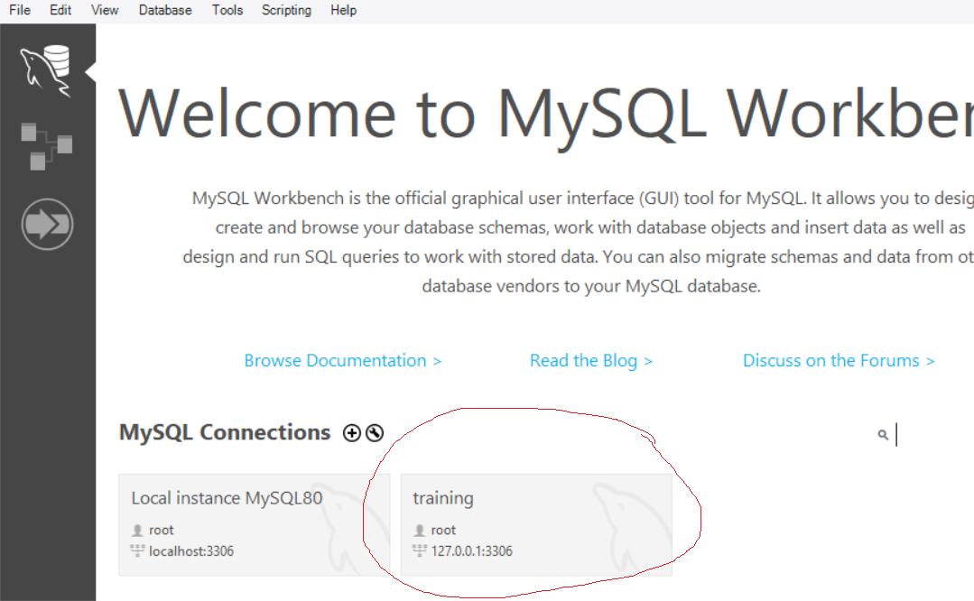

Click on it to start working
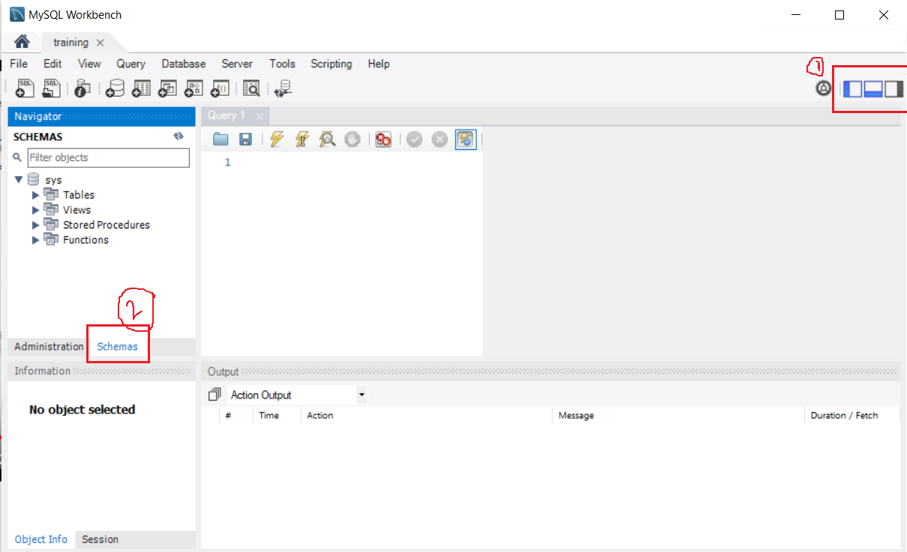
I got the above dashboard. I can hide the navigator pane on LHS and the output pane (below) by clicking appropriate icons on top right (1). Choose the schema tab (2). I can create a new schema by right click -> new schema
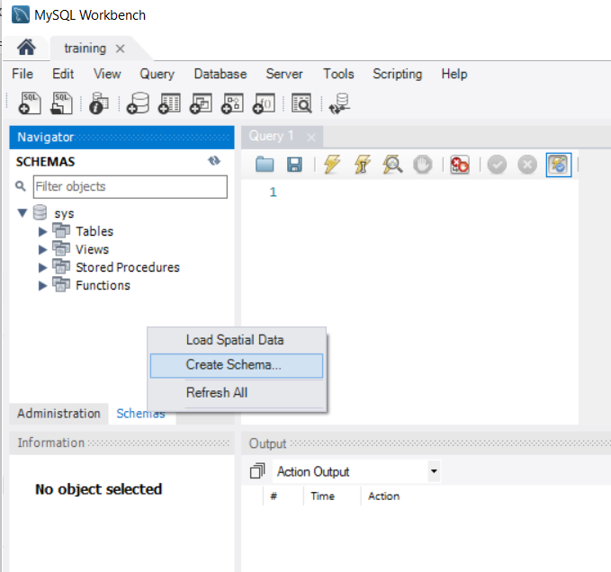

But instead I choose the default schema (sys) and set it as default schema:
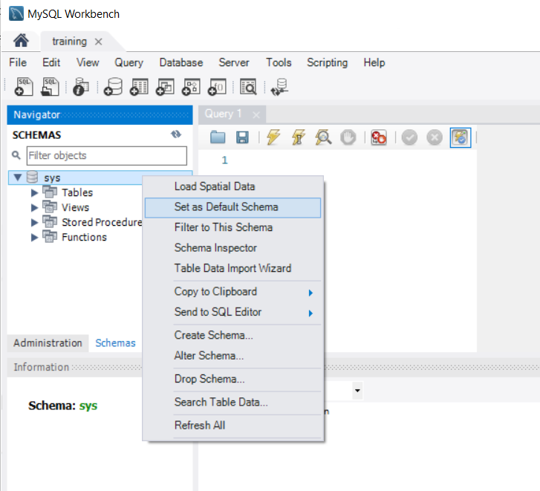

So whatever queries/SQL I write in Query pane will be executed in this database
Now either type CREATE TABLE… in query pane or right click Table -> Create Table…
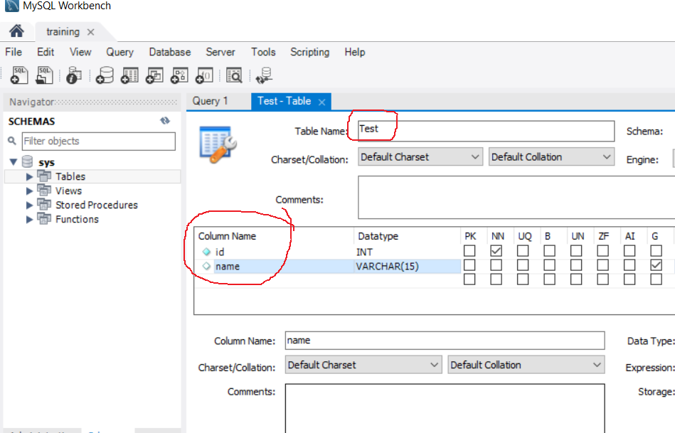

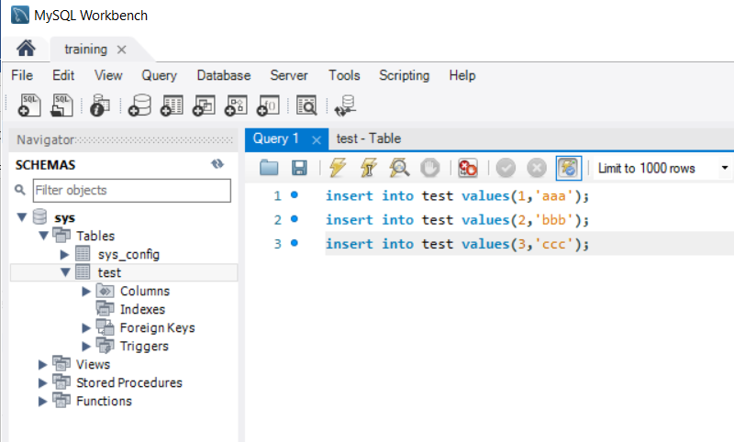

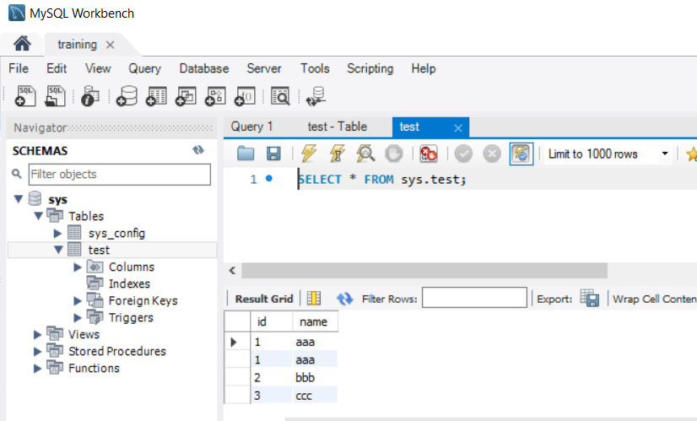

To clear screen in MySql Command Client: system cls
To create database and use it:
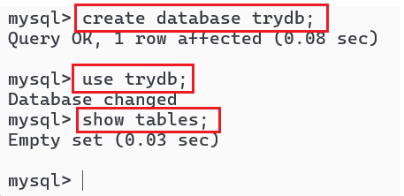n
To run a .sql file in command prompt:
mysql> use db_name;
mysql> source backup-file.sql;

To see table structure : desc <table name>

